CUSTOMER CARE REGISTRY

PROJECT REPORT

Submitted by

TEAM ID: PNT2022TMID04476

SATHANA (737819CSR182)

SRUTHI (737819CSR195)

SRIRAKESH (737819CSR191)

VIJAI (737819CSR222)

CHAPTER NO  1 | TITLE  INTRODUCTION
 | 1.1 Project Overview
 | 1.2 Purpose
2 | LITERATURE SURVEY
 | 2.1 Existing problem
 | 2.2 References
 | 2.3 Problem Statement Definition
3 | IDEATION & PROPOSED SOLUTION
 | 3.1 Empathy Map Canvas
 | 3.2 Ideation & Brainstorming
 | 3.3 Proposed Solution
 | 3.4 Problem Solution fit
4 | REQUIREMENT ANALYSIS
 | 4.1 Functional requirement
 | 4.2 Non-Functional requirements
5 | PROJECT DESIGN
 | 5.1 Data Flow Diagrams
5.2 Solution & Technical Architecture
5.3 User Stories
- PROJECT PLANNING & SCHEDULING
  - Sprint Planning & Estimation
  - Sprint Delivery Schedule
  - Reports from JIRA
- CODING & SOLUTIONING
  - Feature 1 ( UI Designing )
  - Feature 2 ( Contact Form )
- TESTING
  - Test Cases
  - User Acceptance Testing
- RESULTS
- ADVANTAGES & DISADVANTAGES
- CONCLUSION

- FUTURE SCOPE
- APPENDIX

INTRODUCTION
Today's development cycles for web-applications such as Portals and Marketplaces are short, and getting shorter with continuous improvements and enhancements as new requirements and features become apparent. On the other side, most of user’s complaints are apparent when a system has inappropriate communication between the organizations, their employees and customers (Citizens). Poor communication can result in poor services or products being provided by the organization. Whilst concentrating on the topic of complaint handling, organizations can achieve an efficient success factor by increasing their user satisfaction and their loyalty. Therefore each organization needs to develop its internal and external communication towards its staff and customers to achieve success. Although appropriate communication can reduce user dissatisfaction; it cannot eliminate complaint. For a Social Solidarity, there is a need for a Customer care registry in order to deal with complaints. Every day Citizens complaint to staff of the service department because of feeling dissatisfied. No matter direct or indirect accusation to any staff, such as face to face complaint, telephone complaint, complaint letter, and message on the web, all the complaints should be accepted and properly cared for. The resolution of the complaint might be economic compensation, improving service and so on. Also it should weight this complaints i.e., weak complaint or strong complaint and take respective measures in order to prioritize handling of complaint. However, many investigations have been done on the topic of recent Researches in Computer Science ISBN: 9781-61804-019-0 291 complaint system, only one researcher focused on in eComplaints System to improve relation between Citizens and Organizations. The Researcher believes in e-Complaint Systems can bring more flexibility for complaint departments to change their complaint services. In this paper the concept of e-CRM, e-complaint were explored first then a new model was presented afterwards the implementation of the new model was discussed.

1.1 Project Overview
This Web Application has been developed to help the customer in processing their complaints. The customers can raise the ticket with a detailed description of the issue. An Agent will be assigned to the Customer to solve the problem. Whenever the agent is assigned to a customer they will be notified with an email alert. Customers can view the status of the ticket till the service is provided.
ADMIN: The main role and responsibility of the admin are to take care of the whole process. Starting from Admin login followed by the agent creation and assigning the customer's complaints. Finally, He will be able to track the work assigned to the agent and a notification will be sent to the customer.
USER: They can register for an account. After the login, they can create the complaint with a description of the problem they are facing. Each user will be assigned with an agent. They can view the status of their complaint.
ADMIN: After the user successfully logged in, then the admin can assign the agents and respond them through mail.

1.2 Purpose
The purpose of the customer care registry project is to develop a centralized database of customer service information that can be accessed by companies in order to improve customer service.
The registry will contain customer service records from a variety of companies, including contact information, customer service ratings, and comments. This information will be used to help companies improve their customer service practices and make informed decisions about customer service policies.
The purpose of this project is to develop a customer care registry for a company. This registry will help the company to track and manage customer care related information. It will also help the company to improve customer care services by providing better and more efficient care to customers.

2. LITERATURE SURVEY
A literature survey was conducted on customer care registry projects. The following is a summary of the findings: It was found that customer care registry projects are typically implemented to improve customer service and/or to reduce costs. In many cases, the registry project is used to streamline customer service processes and/or to reduce the number of customer service calls. In some cases, the registry project is used to improve customer satisfaction scores. It was also found that customer care registry projects can be implemented using a variety of different technologies, including web-based applications, customer relationship management (CRM) systems, and enterprise resource planning (ERP) systems. In some cases, the registry project is implemented using a combination of different technologies. Finally, it was found that customer care registry projects can be successful if they are properly planned and implemented. However, if the project is not properly planned or implemented, it is likely to fail. 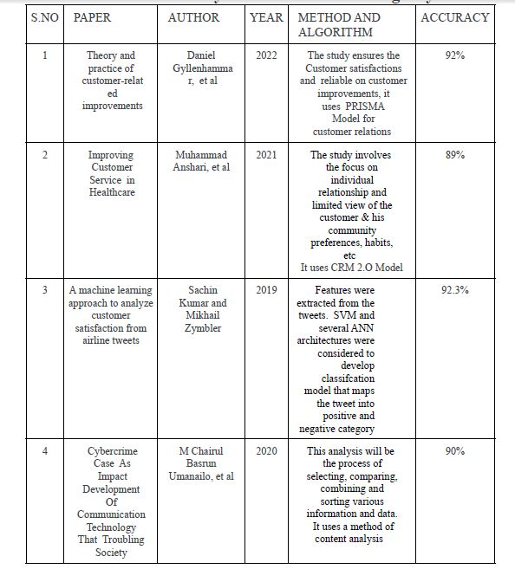
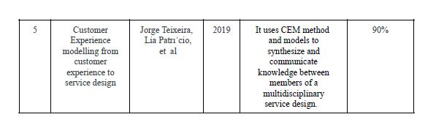

2.1Existing problem
The existing system for the customer care registry project is a paper-based system. This system is used to track customer service requests and complaints. The system is cumbersome and time-consuming, and it is difficult to track and report on customer service issues. The customer care registry project is designed to replace the existing system with a new, web-based system. The new system will be easier to use and will provide more accurate and timely information on customer service issues.Out of the previous related work done concerning customer complaint, the most recent research was: Razali et al. (2011) [6] develop a new complaint management system called (e-
Aduan) as a platform for UiTM Pahang’s customers to complaint and comment regarding the services and facilities provided by the university. The researcher found out that the most appropriate to the research topic handling customer complaint using SOA was: Najar et al. (2010) [5] tried to improve relation between Citizens and Government by presenting a new model based on Service Oriented Architecture (SOA). With utilizing the presented model in Government body on one hand Governments will have the ability to minimize Citizens' dissatisfaction and on the other hand it can encourage Citizens to participate in controlling Government body such as Governments' staffs and organizations.

2.2References
[1] Cho Y., Hiltz R., & Fjermestad J., “An Analysis of Online Customer Complaints:
Implications for Web Complaint Management.” in Proceedings of the 35th Hawaii International Conference on System Sciences, Hawaii, (2002).
- Najar, A. S., Al-Sukhni, H. A., & Aghakhani, N., “The Application of Service-
Oriented Architecture in E-complaint System.” Paper presented at (ICCSN '10) the Second International Conference on Communication Software and Networks, (2010, 2628 Feb. 2010).
- Razali R., Abd Halim K. N., & Jusoff K., “Quality Improvement of Services in
Unversiti Teknologi Mara Pahang from a Management Perspective.” Management Science & Engineering Vol.5, No.1, (2011), pp. 71-80.

2.3Problem Statement Definition
A problem statement is a clear and concise description of the problem or issue a team aims to address in a project. It identifies a problem’s current state, desired future state, and the gaps that lie between the two. It doesn't define the solution to the problem or provide a road map for solving the problem; it only gives an outline of what the problem is.

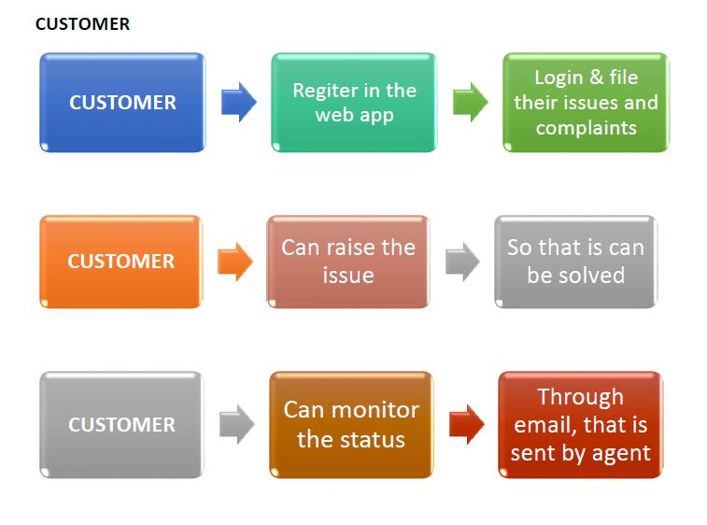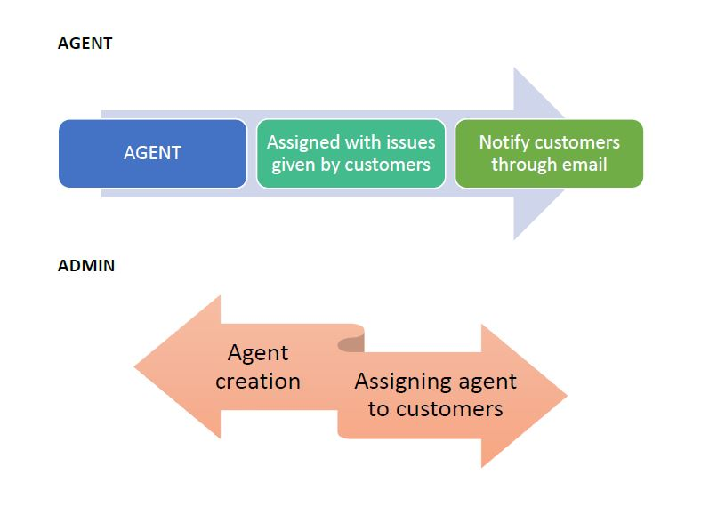

3. IDEATION & PROPOSED SOLUTION

3.1Empathy Map Canvas
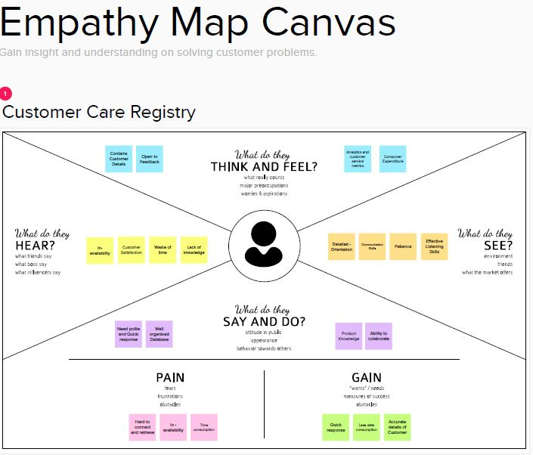

3.2 Ideation & Brainstorming
Brainstorming provides a free and open environment that encourages everyone within a team to participate in the creative thinking process that leads to problem solving. Prioritizing volume over value, out-of-the-box ideas are welcome and built upon, and all participants are encouraged to collaborate, helping each other develop a rich amount of creative solutions.
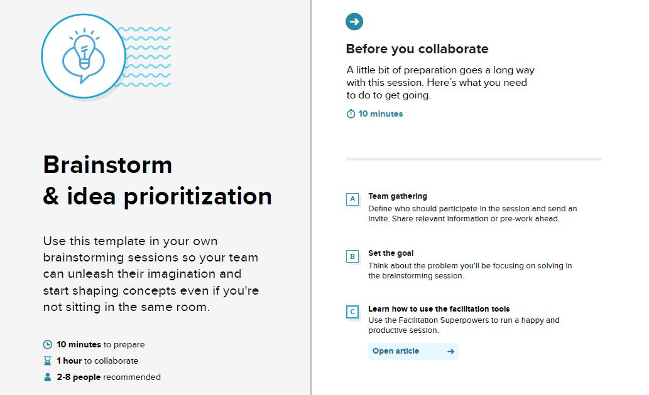
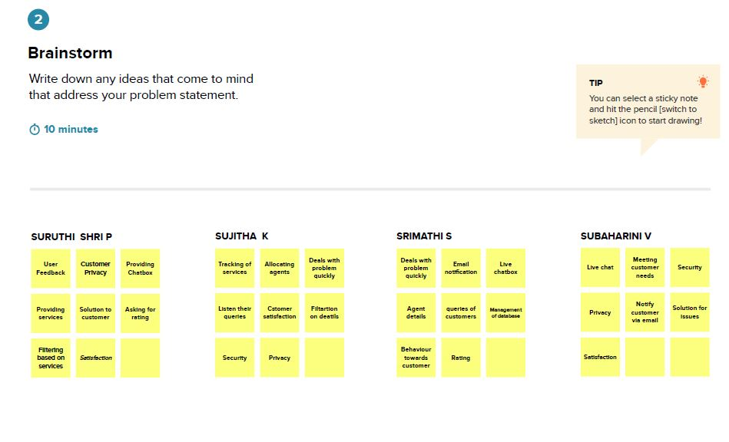
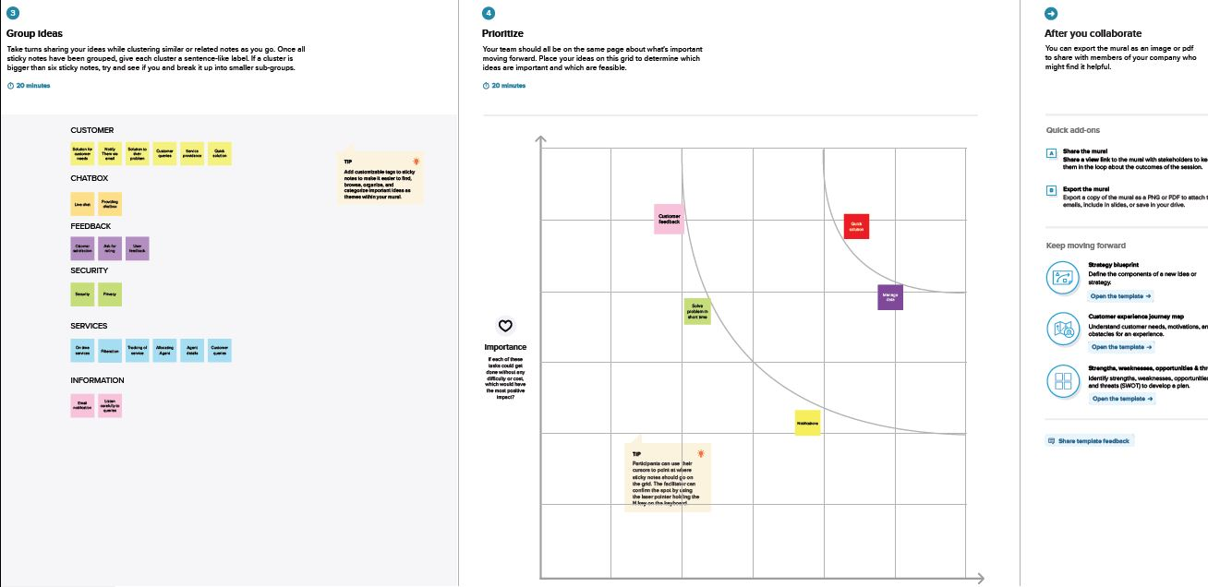

3.3 Proposed Solution
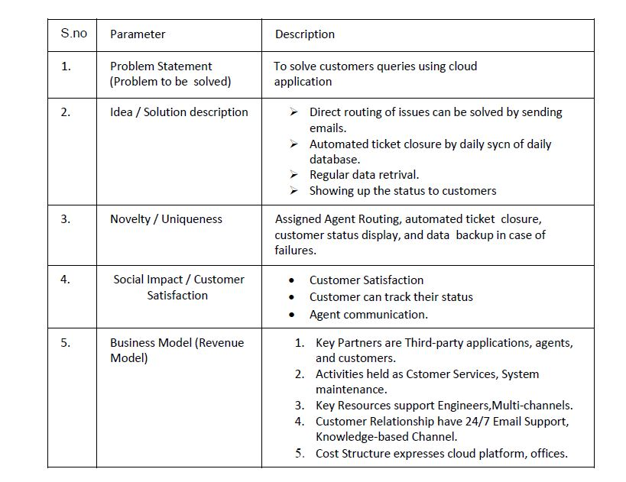

3.4 Problem Solution Fit
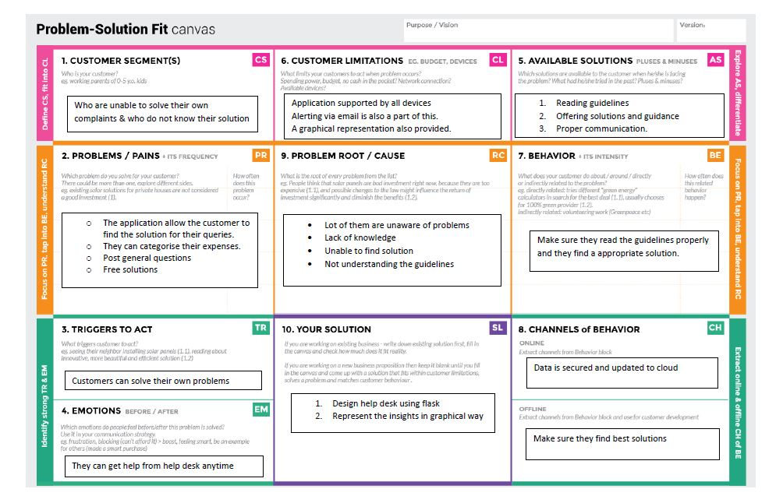

4. REQUIREMENT ANALYSIS
Requirements analysis, also called requirements engineering, is the process of determining user expectations for a new or modified product. These features, called requirements, must be quantifiable, relevant and detailed. In software engineering, such requirements are often called functional specifications. The main types of requirements analysis include business, customer, product, functional, and nonfunctional requirements. Each one represents a stakeholder or stage of the project and communicates the project needs.

4.1 Functional Requirements

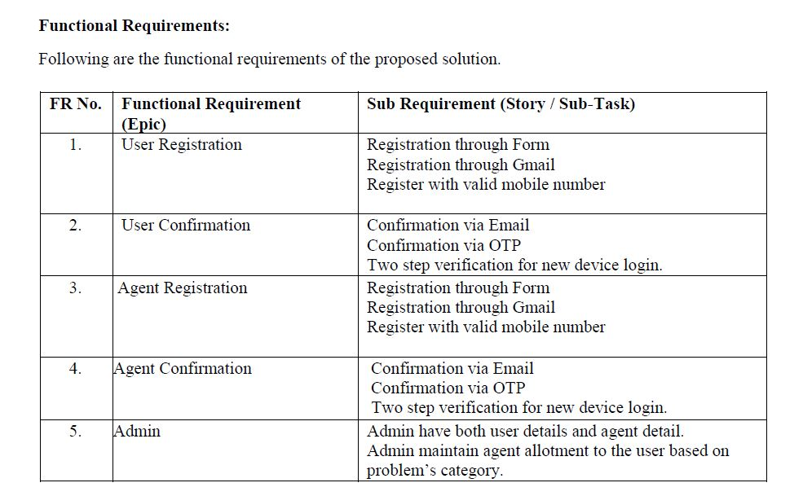

4.2 Non-functional Requirements

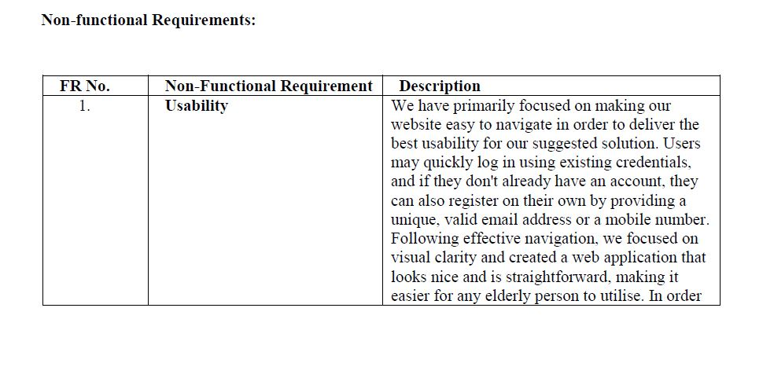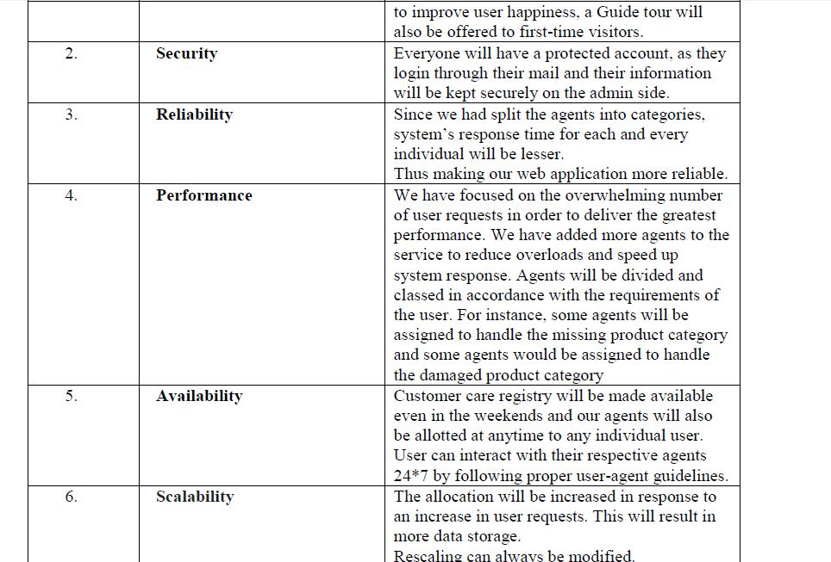

5. PROJECT DESIGN
5.1 Data Flow Diagrams:
A Data Flow Diagram (DFD) is a traditional visual representation of the information flows within a system. A neat and clear DFD can depict the right amount of the system requirement graphically. It shows how data enters and leaves the system, what changes the information, and where data is stored.
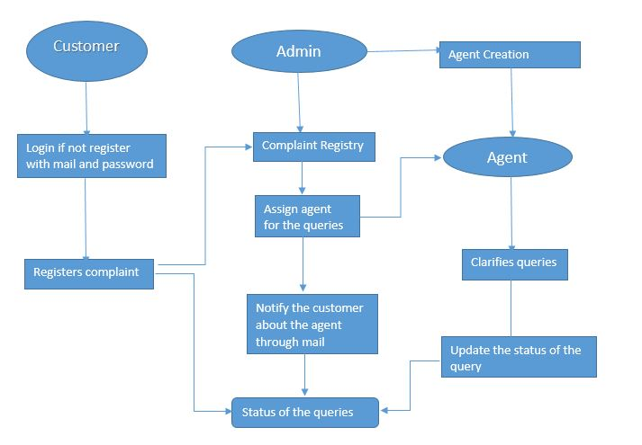

5.2Solution and Technical Architecture

Assigned Agent routing can be solved by directly routing to the specific agent about the issue using the specific E-mail. Automated Ticket closure by using daily sync of the daily database. Status Shown to the Customer can display the status of the ticket to the customer.
Regular data retrieval in the form of retrieving lost data.

Solution Architecture:
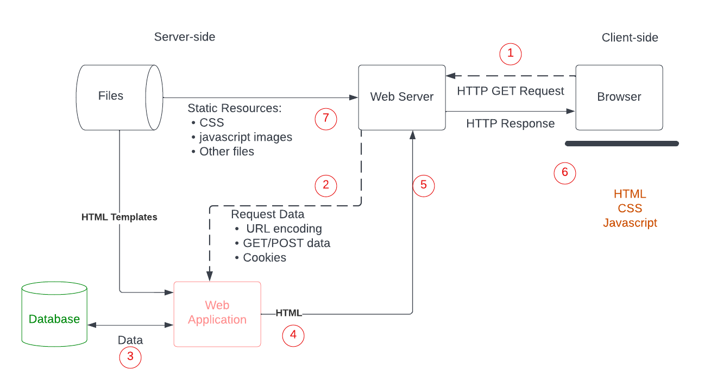

Technical Architecture:
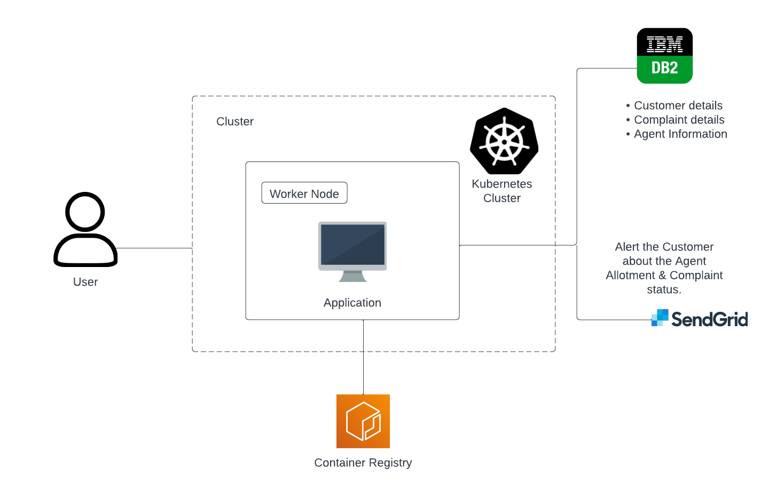
  - User Stories
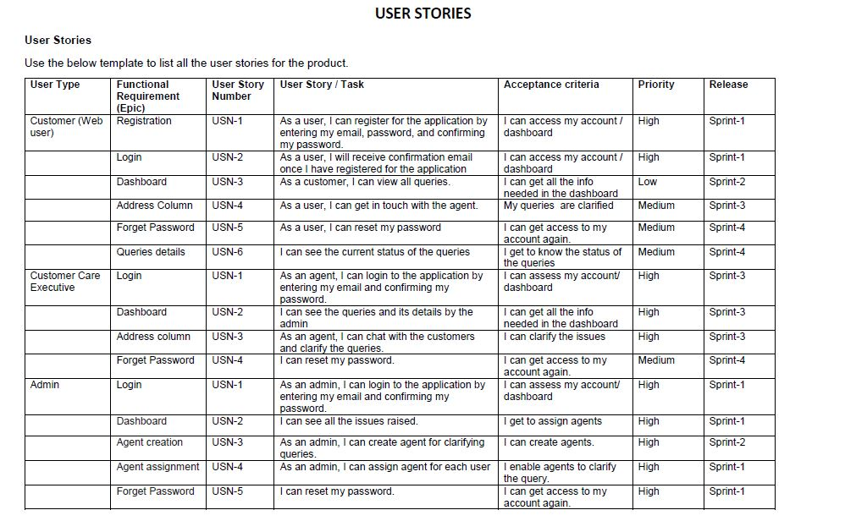

6 PROJECT PLANNING & SCHEDULING

6.1 Sprint Planning & Estimation
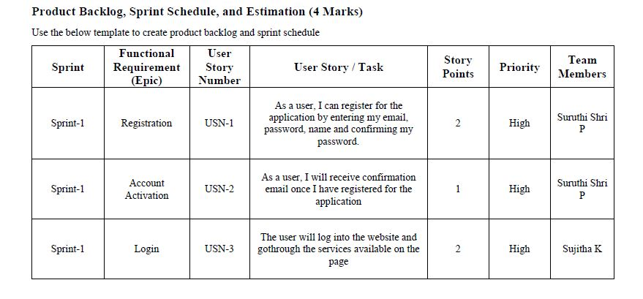
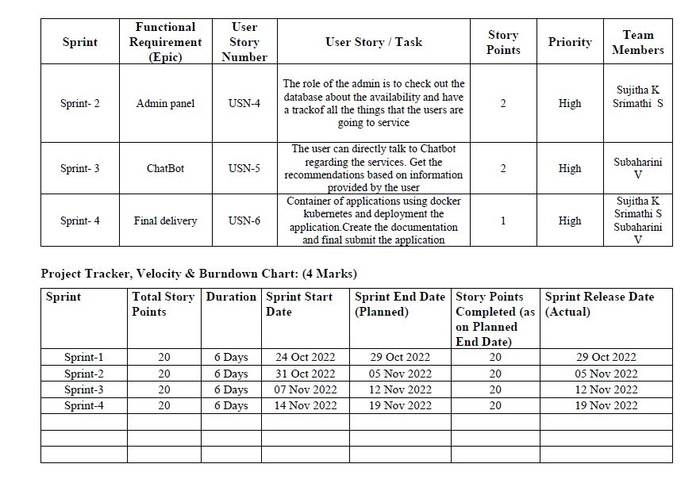

  - Sprint Delivery Schedule

6.3 Reports from JIRA

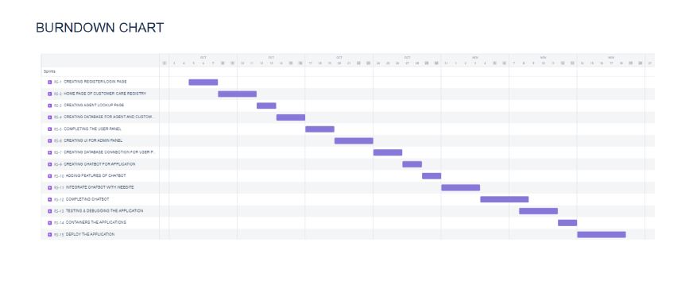

7. CODING & SOLUTIONING

Register.html

<!DOCTYPE html>
<html>
<head>
<link rel="stylesheet" href="styles/styles.css" />
<link
rel="stylesheet"
href="https://use.fontawesome.com/releases/v5.15.4/css/all.css"
/>
<link
rel="stylesheet"
href="https://cdnjs.cloudflare.com/ajax/libs/font-awesome/6.0.0-beta2/css/all.min.css"
/>
<link
rel="stylesheet"
href="https://cdn.jsdelivr.net/npm/cooltipz-css/cooltipz.css"
/>
<link
rel="stylesheet"
href="https://cdn.jsdelivr.net/npm/bootstrap-icons@1.3.0/font/bootstrap-icons.css"
/>
<link rel="icon" type="image/x-icon" href="./assets/favicon-icon.png" />
<title>Customer registry</title>
</head>

<body>
<h1 class="sign-up">Sign Up</h1>
<h4 class="sign-up slogan">
It's completely free and takes only a minute
</h4>
<div class="signup-form">
<label for="username" class="user-details">Name</label>
<input
type="text"
placeholder=""
id="username"
class="form-input"
minlength="5"
maxlength="15"
spellcheck="false"
/>
<label for="user-email" class="user-details">E-Mail </label>
<input
type="email"
placeholder=""
id="user-email"
class="form-input"
spellcheck="false"
/>
<label for="user-types" class="user-details user-type"
>User Type</label
>
<div class="user-type-box">
<div class="form-input custom-select" id="user-types-box">
<p id="user-types">Select User Type...</p>
<p>
<i class="fa fa-sharp fa-solid fa-sort-down"></i>
</p>
</div>
<div>
<ul class="user-type-options" id="user-type-options">
<li class="options" onclick="writeToSelect('Student')">
Student
</li>
<li class="options" onclick="writeToSelect('Professional')">
Professional
</li>
</ul>
</div>
</div>
<label for="password" class="user-details">Password </label>
<div class="password-container">
<input
type="password"
placeholder=""
id="password"
class="form-input password-field"
minlength="8"
maxlength="15"
autocomplete="off"
onclick="passwordValidation()"
/><i class="fa fa-eye eye-button" id="password-eye"></i>
</div>
<div class="password-requirement">
Password Requirements :
<ul>
<li>Minimum 8 and Maximum 15 characters</li>
<li>Atleast 1 special character,1 alphabet,1 number</li>
</ul>
</div>
<label for="confirm-password" class="user-details"
>Confirm Password
</label>
<div class="password-container">
<input
type="password"
placeholder=""
id="confirm-password"
class="form-input password-field"
minlength="8"
maxlength="15"
autocomplete="off"
onclick="passwordValidation()"
/>
<i
class="fa fa-eye eye-button"
id="confirm-password-eye"
aria-hidden="true"
></i>
</div>
</div>
<div class="mandatory-message">* Mandatory fields</div>
<input
type="Submit"
value="Sign Up"
class="signup-button"
id="signup-button"
onclick="signupValidation()"
/>
<p class="user-login">
Already have an account ?
<a class="user-login-redirect" onclick="redirectLoginPage()"
>Login Here</a
>
</p>
</body>
</html>

Login.html
<!DOCTYPE html>
<html lang="en">
<head>
<meta charset="UTF-8">
<meta http-equiv="X-UA-Compatible" content="IE=edge">
<meta name="viewport" content="width=device-width, initial-scale=1.0">
<link rel="stylesheet" href="styles/styles.css" />
<link
rel="stylesheet"
href="https://use.fontawesome.com/releases/v5.15.4/css/all.css"
/>
<link
rel="stylesheet"
href="https://cdnjs.cloudflare.com/ajax/libs/font-awesome/6.0.0-beta2/css/all.min.css"
/>
<link
rel="stylesheet"
href="https://cdn.jsdelivr.net/npm/cooltipz-css/cooltipz.css"
/>
<link
rel="stylesheet"
href="https://cdn.jsdelivr.net/npm/bootstrap-icons@1.3.0/font/bootstrap-icons.css"
/>
<link rel="icon" type="image/x-icon" href="./assets/favicon-icon.png" />
<title>Customer registry</title>
</head>
<body>
<div class="signup-page" id="logo-section">
<div class="logo-section">
<div class="logo">
<i class="fa fa-light fa-clipboard-list logo-icon"></i>
Customer care registry App
</div>
</div>
<div class="signup-box hide-signup" id="signup-page">
<div id="snackbar" class="snackbar">
User Already Exists.. Try Signingup with another E-Mail
<button class="snackbar-close" id="snackbar-close">X</button>
</div>
<h1 class="sign-up">Sign Up</h1>
<h4 class="sign-up slogan">
It's completely free and takes only a minute
</h4>
<div class="signup-form">
<label for="username" class="user-details">Name</label>
<input
type="text"
placeholder=""
id="username"
class="form-input"
minlength="5"
maxlength="15"
spellcheck="false"
/>
<label for="user-email" class="user-details">E-Mail </label>
<input
type="email"
placeholder=""
id="user-email"
class="form-input"
spellcheck="false"
/>
<label for="user-types" class="user-details user-type"
>User Type</label
>
<div class="user-type-box">
<div class="form-input custom-select" id="user-types-box">
<p id="user-types">Select User Type...</p>
<p>
<i class="fa fa-sharp fa-solid fa-sort-down"></i>
</p>
</div>
<div>
<ul class="user-type-options" id="user-type-options">
<li class="options" onclick="writeToSelect('Student')">
Student
</li>
<li class="options" onclick="writeToSelect('Professional')">
Professional
</li>
</ul>
</div>
</div>
<label for="password" class="user-details">Password </label>
<div class="password-container">
<input
type="password"
placeholder=""
id="password"
class="form-input password-field"
minlength="8"
maxlength="15"
autocomplete="off"
onclick="passwordValidation()"
/><i class="fa fa-eye eye-button" id="password-eye"></i>
</div>
<div class="password-requirement">
Password Requirements :
<ul>
<li>Minimum 8 and Maximum 15 characters</li>
<li>Atleast 1 special character,1 alphabet,1 number</li>
</ul>
</div>
<label for="confirm-password" class="user-details"
>Confirm Password
</label>
<div class="password-container">
<input
type="password"
placeholder=""
id="confirm-password"
class="form-input password-field"
minlength="8"
maxlength="15"
autocomplete="off"
onclick="passwordValidation()"
/>
<i
class="fa fa-eye eye-button"
id="confirm-password-eye"
aria-hidden="true"
></i>
</div>
</div>
<div class="mandatory-message">* Mandatory fields</div>
<input
type="Submit"
value="Sign Up"
class="signup-button"
id="signup-button"
onclick="signupValidation()"
/>
<p class="user-login">
Already have an account ?
<a class="user-login-redirect" onclick="redirectLoginPage()"
>Login Here</a
>
</p>
</div>
<div class="signup-box login-box" id="login-page">
<div id="login-snackbar" class="snackbar">
SignUp successful. Login to Continue
<button class="snackbar-close" id="login-snackbar-close">X</button>
</div>
<div id="login-snackbar-failed" class="snackbar">
Invalid Credentials. Please check email or Password
<button class="snackbar-close" id="login-snackbar-failed-close">
X
</button>
</div>
<div id="login-snackbar-notfound" class="snackbar login-wrong-snackbar">
User Not Found.. SignUp to continue
<button class="snackbar-close" id="login-snackbar-failed-notfound">
X
</button>
</div>
<h1 class="sign-up">Login</h1>

</div>
</body>
</html>

@import "start-page.css";
@import "dashboard.css";

* {
margin: 0;
padding: 0;
}

body {
font-family: "Segoe UI", Tahoma, Geneva, Verdana, sans-serif;
}

Home.html
<!DOCTYPE html>
<html lang="en">
<head>
<meta charset="UTF-8">
<meta http-equiv="X-UA-Compatible" content="IE=edge">
<meta name="viewport" content="width=device-width, initial-scale=1.0">
<title>Chat bot</title>
<link rel="stylesheet" href="style.css">
</head>
<body>
<link href="https://fonts.googleapis.com/css?family=Amatic+SC|Raleway" rel="stylesheet">
<link rel="stylesheet" href="https://maxcdn.bootstrapcdn.com/font-awesome/4.7.0/css/font-awesome.min.css">
<link rel="stylesheet" href="assets/css/styles.css">
</head>
<body>
<!-- Forked from a template on Tutorialzine: https://tutorialzine.com/2016/06/freebie-landing-page-template-with-flexbox -->
<header>
<h2><a href="#">Customer Care Registory</a></h2>
<nav>

</nav>
</header>

<section class="hero">
<div class="background-image"></div>
<div class="hero-content-area">
<h1>Customer Care Registory</h1>
<h3>Tell your problem we will quick solve it</h3>
<a href="#" class="btn">Contact Us Now</a>
</div>
</section>

</body>
<script>
window.watsonAssistantChatOptions = {
integrationID: "9167fb91-f51e-49bc-9845-d1a925946b54", // The ID of this integration.
region: "jp-tok", // The region your integration is hosted in.
serviceInstanceID: "61644cb2-75a6-49e3-857e-97e947c8c678", // The ID of your service instance.
onLoad: function(instance) { instance.render(); }
};
setTimeout(function(){
const t=document.createElement('script');
t.src="https://web-chat.global.assistant.watson.appdomain.cloud/versions/" + (window.watsonAssistantChatOptions.clientVersion || 'latest') + "/WatsonAssistantChatEntry.js";
document.head.appendChild(t);
});
</script>
</html>

Form.html
<!DOCTYPE html>
<html>
<head>
<meta name="viewport" content="width=device-width, initial-scale=1">
<style>
body {font-family: Arial, Helvetica, sans-serif;}
* {box-sizing: border-box;}

input[type=text], select, textarea {
width: 100%;
padding: 12px;
border: 1px solid #ccc;
border-radius: 4px;
box-sizing: border-box;
margin-top: 6px;
margin-bottom: 16px;
resize: vertical;
}

input[type=submit] {
background-color: #04AA6D;
color: white;
padding: 12px 20px;
border: none;
border-radius: 4px;
cursor: pointer;
}

input[type=submit]:hover {
background-color: #45a049;
}

.container {
border-radius: 5px;
background-color: #f2f2f2;
padding: 20px;
}
</style>
</head>
<body>

<h3>Contact Form</h3>

<div class="container">
<div class="msg">{{ msg }}</div>
<form method="POST" id="myForm" action="{{url_for('form')}}">
<label for="subject">subject</label>
<input type="text" id="subject" name="subject" placeholder="Your Email..">
<label for="fname"> Name</label>
<input type="text" id="username" name="name" placeholder="Your name..">

<label for="lname">Email</label>
<input type="text" id="email" name="email" placeholder="Your Email..">

<label for="country">Suppoter</label>
<select id="suppoter" name="suppoter">
<option value="tamil">Tamil</option>
<option value="kaml">kamal</option>
<option value="john">john</option>
<option value="hentry">hentry</option>
</select>

<label for="msg">Your Queries</label>
<textarea id="query" name="query" placeholder="Write something.." style="height:200px"></textarea>

<input type="submit" value="Submit">
</form>
<script type="text/javascript">
document.forms['suppoter']['suppoter'].value = "New value";
</script>
</div>

</body>
</html>

Success.html
<h1>Your complaint is send to agent</h1>
<a href="/customer">back</a>

Css
.signup-page {
align-items: center;
background-color: #f7f5f5;
display: flex;
flex-direction: column;
height: 100vh;
justify-content: center;
}

.signup-box {
background-color: white;
border-radius: 5px;
height: 653px;
text-align: center;
width: 360px;
}

.sign-up {
padding: 8px 0 0 17px;
text-align: left;
}

.slogan {
padding-top: 0;
}

.logo-section {
margin-bottom: 15px;
width: 250px;
}

.logo {
align-items: center;
background-color: #d0d0d0;
border-radius: 10px;
color: #00416a;
display: flex;
font-size: 30px;
font-weight: bolder;
justify-content: center;
padding: 5px;
}

.logo-icon {
color: #005a9c;
margin-right: 10px;
}

.planner-logo {
height: 40px;
width: 40px;
}

.hide-cards {
display: none;
}

.signup-form {
font-size: 20px;
margin-left: 20px;
width: 300px;
}

.user-details {
display: flex;
margin-top: 15px;
}

.form-input {
border: none;
border: 1px solid grey;
border-radius: 7px;
margin-top: 7px;
outline: none;
padding: 7px;
width: 100%;
}

.password-field {
border-radius: 7px 0 0 7px;
border-right: none;
}

.password-requirement {
text-align: start;
font-size: 12px;
}

.password-requirement li {
margin-left: 15px;
}

.password-container {
display: flex;
}

.eye-button {
background: none;
border: 1px solid grey;
border-radius: 0 7px 7px 0;
border-left: none;
cursor: pointer;
font-size: 17px;
margin: 7px -16px 0 0;
padding: 7px;
}

.signup-button {
background-color: #49c1a2;
border: none;
border-radius: 7px;
color: white;
cursor: pointer;
font-size: 18px;
height: 35px;
margin-top: 20px;
width: 320px;
}

.user-login {
font-size: 18px;
margin-top: 15px;
text-align: center;
}

.user-types {
font-size: 16px;
text-align: center;
width: 315px;
}

.user-details::after {
content: "*";
color: red;
}

.mandatory-message {
color: red;
margin-left: 20px;
text-align: start;
}

#login-page .mandatory-message {
margin-top: 15px;
}

#signup-page .mandatory-message {
margin-top: 5px;
}

.user-type::after {
content: "";
}

.hide-signup {
display: block;
}

.login-box {
display: block;
height: 450px;
}

.login-form {
margin-top: 40px;
}

.login-button {
margin-top: 25px;
}

.snackbar {
bottom: 89%;
border-radius: 10px;
color: white;
display: flex;
font-size: 17px;
left: 44%;
min-width: 250px;
margin-left: -100px;
padding: 5px;
position: fixed;
text-align: center;
visibility: hidden;
z-index: 1;
}

.snackbar-close {
background: none;
border: none;
cursor: pointer;
align-self: start;
margin-left: 5px;
}

.signup-success {
animation: fadein 0.5s, fadeout 0.5s 2.5s;
background-color: #4cbb17;
bottom: 88%;
left: 47%;
visibility: visible;
-webkit-animation: fadein 0.5s, fadeout 0.5s 2.5s;
}

.login-wrong-snackbar {
bottom: 93%;
}

.show-snackbar {
animation: fadein 0.5s, fadeout 0.5s 2.5s;
background-color: #ff6347;
visibility: visible;
-webkit-animation: fadein 0.5s, fadeout 0.5s 2.5s;
}

.show-snackbar-error {
animation: fadein 0.5s, fadeout 0.5s 2.5s;
bottom: 99%;
background-color: #ff6347;
left: 38%;
visibility: visible;
-webkit-animation: fadein 0.5s, fadeout 0.5s 2.5s;
}

.custom-select {
align-items: center;
box-sizing: border-box;
cursor: pointer;
display: flex;
font-size: 14px;
justify-content: space-between;
width: 105%;
}

.user-type-options {
background: #f7f5f5;
border-radius: 10px;
display: none;
overflow: hidden;
position: absolute;
text-align: start;
width: 105%;
}

.options {
box-sizing: border-box;
cursor: pointer;
list-style: none;
padding: 5px;
}

.hide-display-options {
display: block;
}

.user-type-box {
position: relative;
}

.options:hover {
background-color: aliceblue;
border: 1px solid grey;
border-radius: 10px;
}

.login-snackbar {
animation: fadein 0.5s, fadeout 0.5s 2.5s;
background-color: #4cbb17;
bottom: 80%;
left: 47%;
visibility: visible;
-webkit-animation: fadein 0.5s, fadeout 0.5s 2.5s;
}

.login-failed-snackbar {
animation: fadein 0.5s, fadeout 0.5s 2.5s;
background-color: #ff6347;
bottom: 89%;
left: 47%;
visibility: visible;
-webkit-animation: fadein 0.5s, fadeout 0.5s 2.5s;
}

.user-login-redirect {
cursor: pointer;
color: blue;
text-decoration: underline;
}

/* Media Queries */

@media (max-width: 1060px) {
.snackbar {
font-size: 17px;
left: 40%;
padding: 7px;
}
}

@media (max-width: 850px) {
.snackbar {
font-size: 15px;
left: 38%;
padding: 4px;
}
}

8. TESTING
8.1 Test Cases
A test case is a document, which has a set of test data, preconditions, expected results and post conditions, developed for a particular test scenario in order to verify compliance against a specific requirement. Test Case acts as the starting point for the test execution, and after applying a set of input values.
9. RESULTS

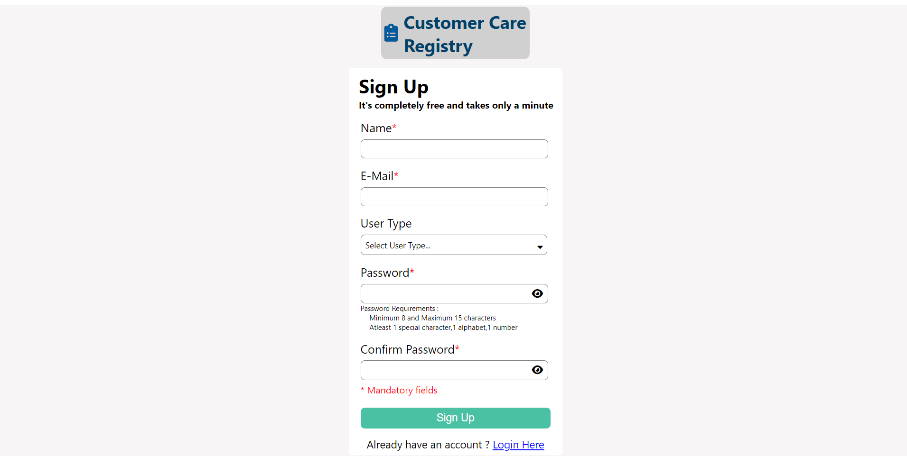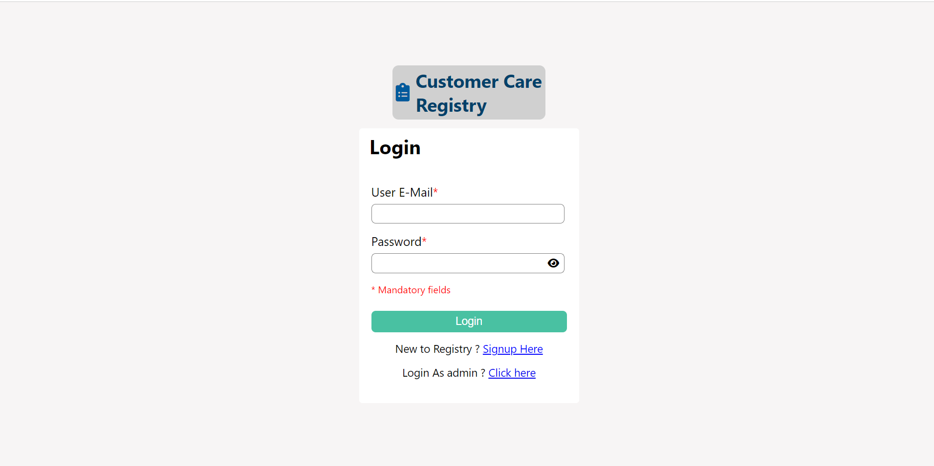
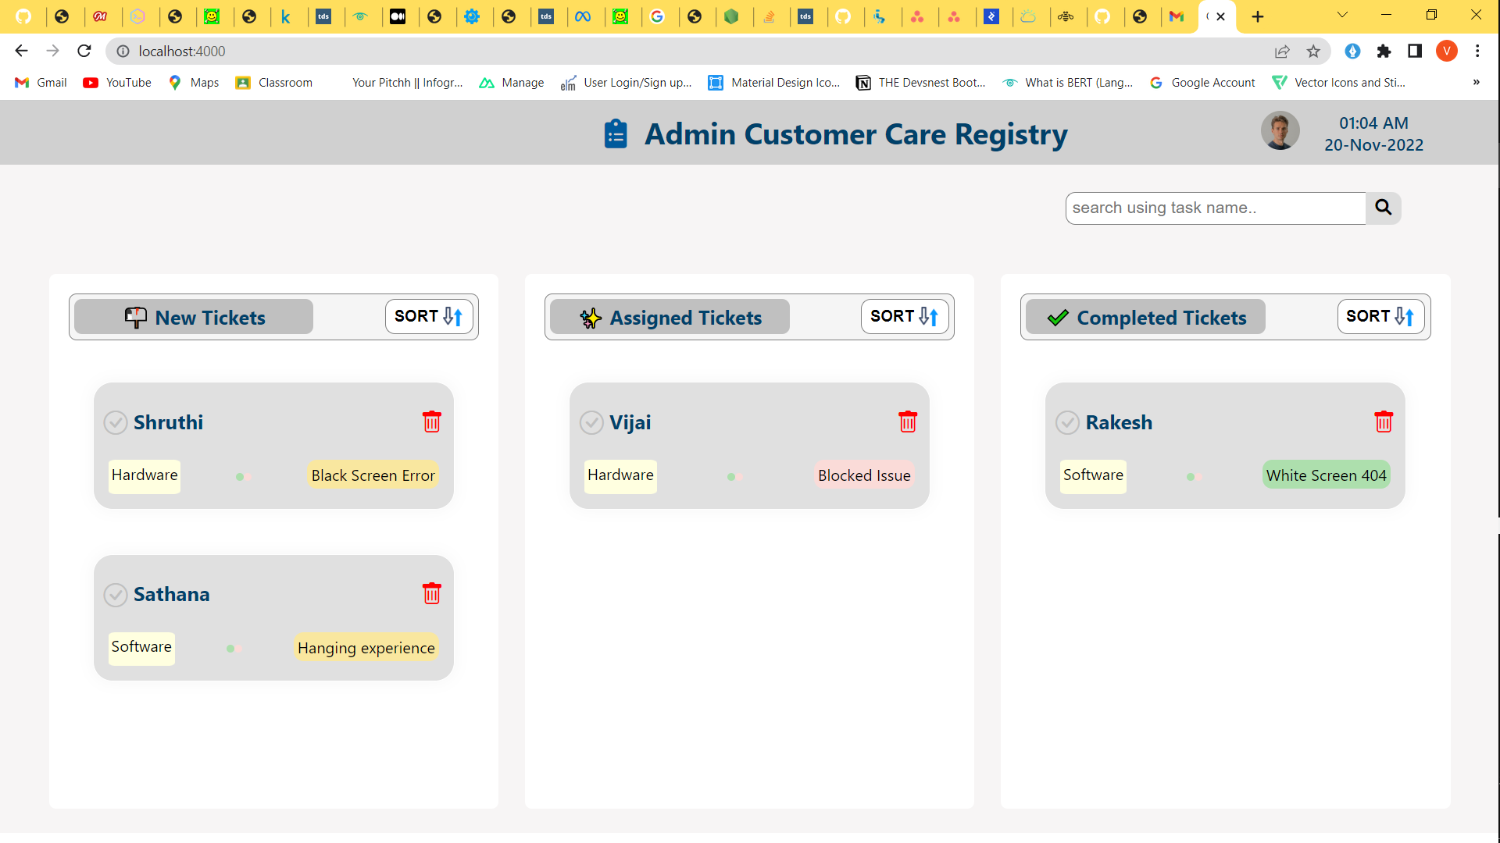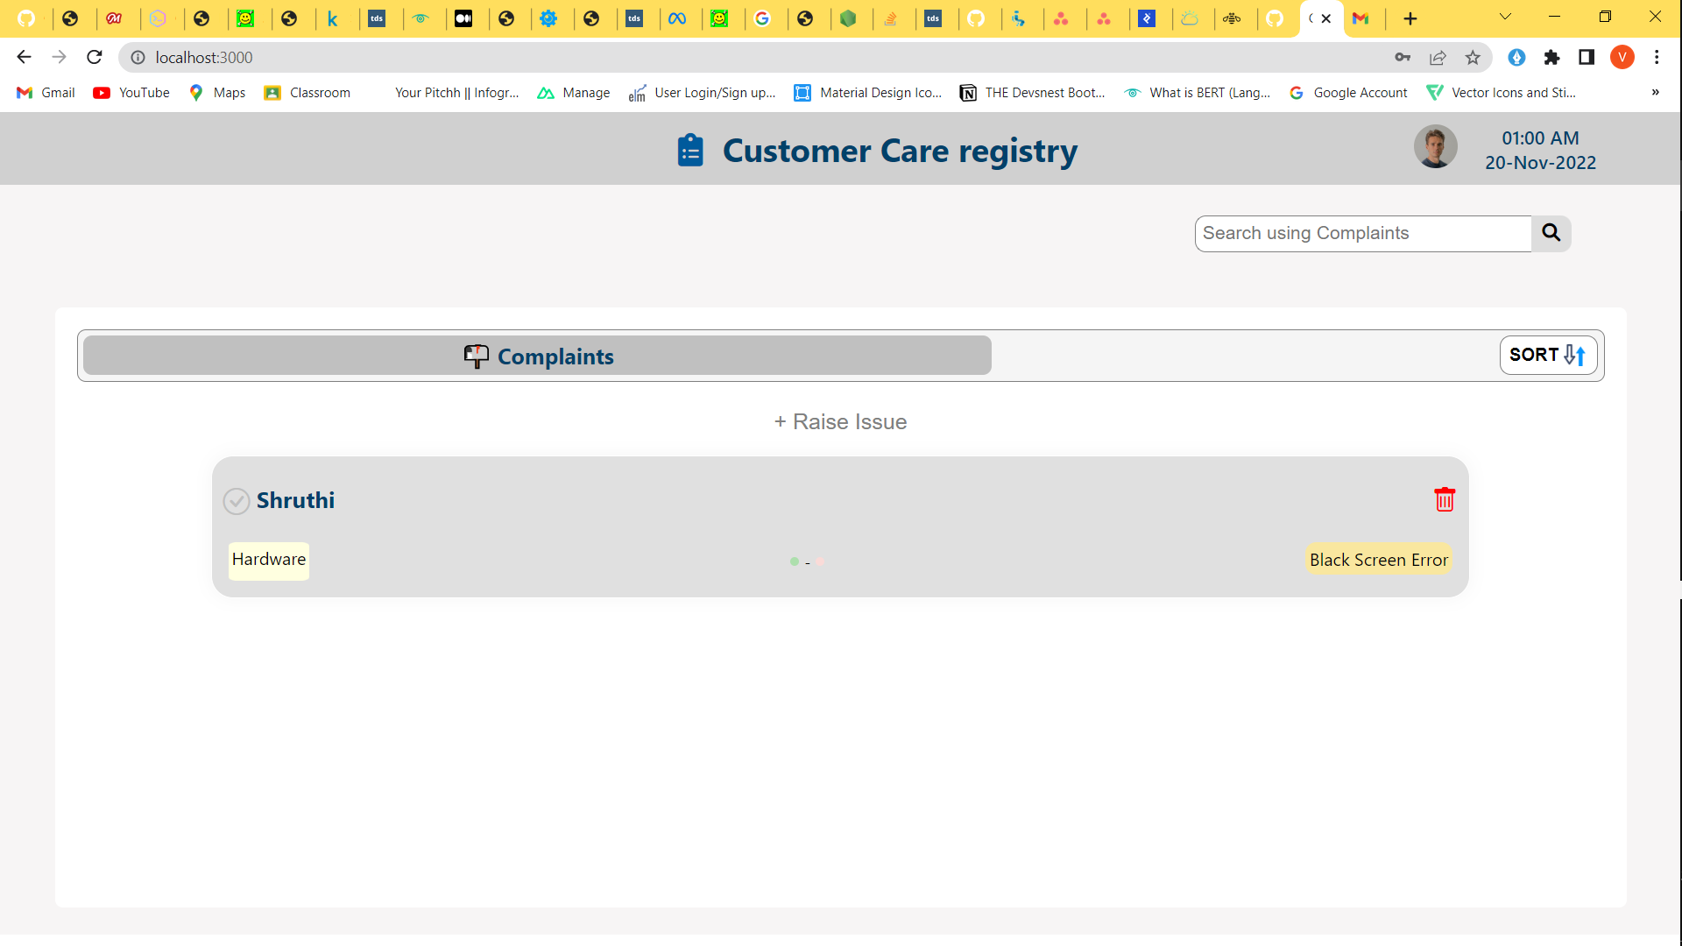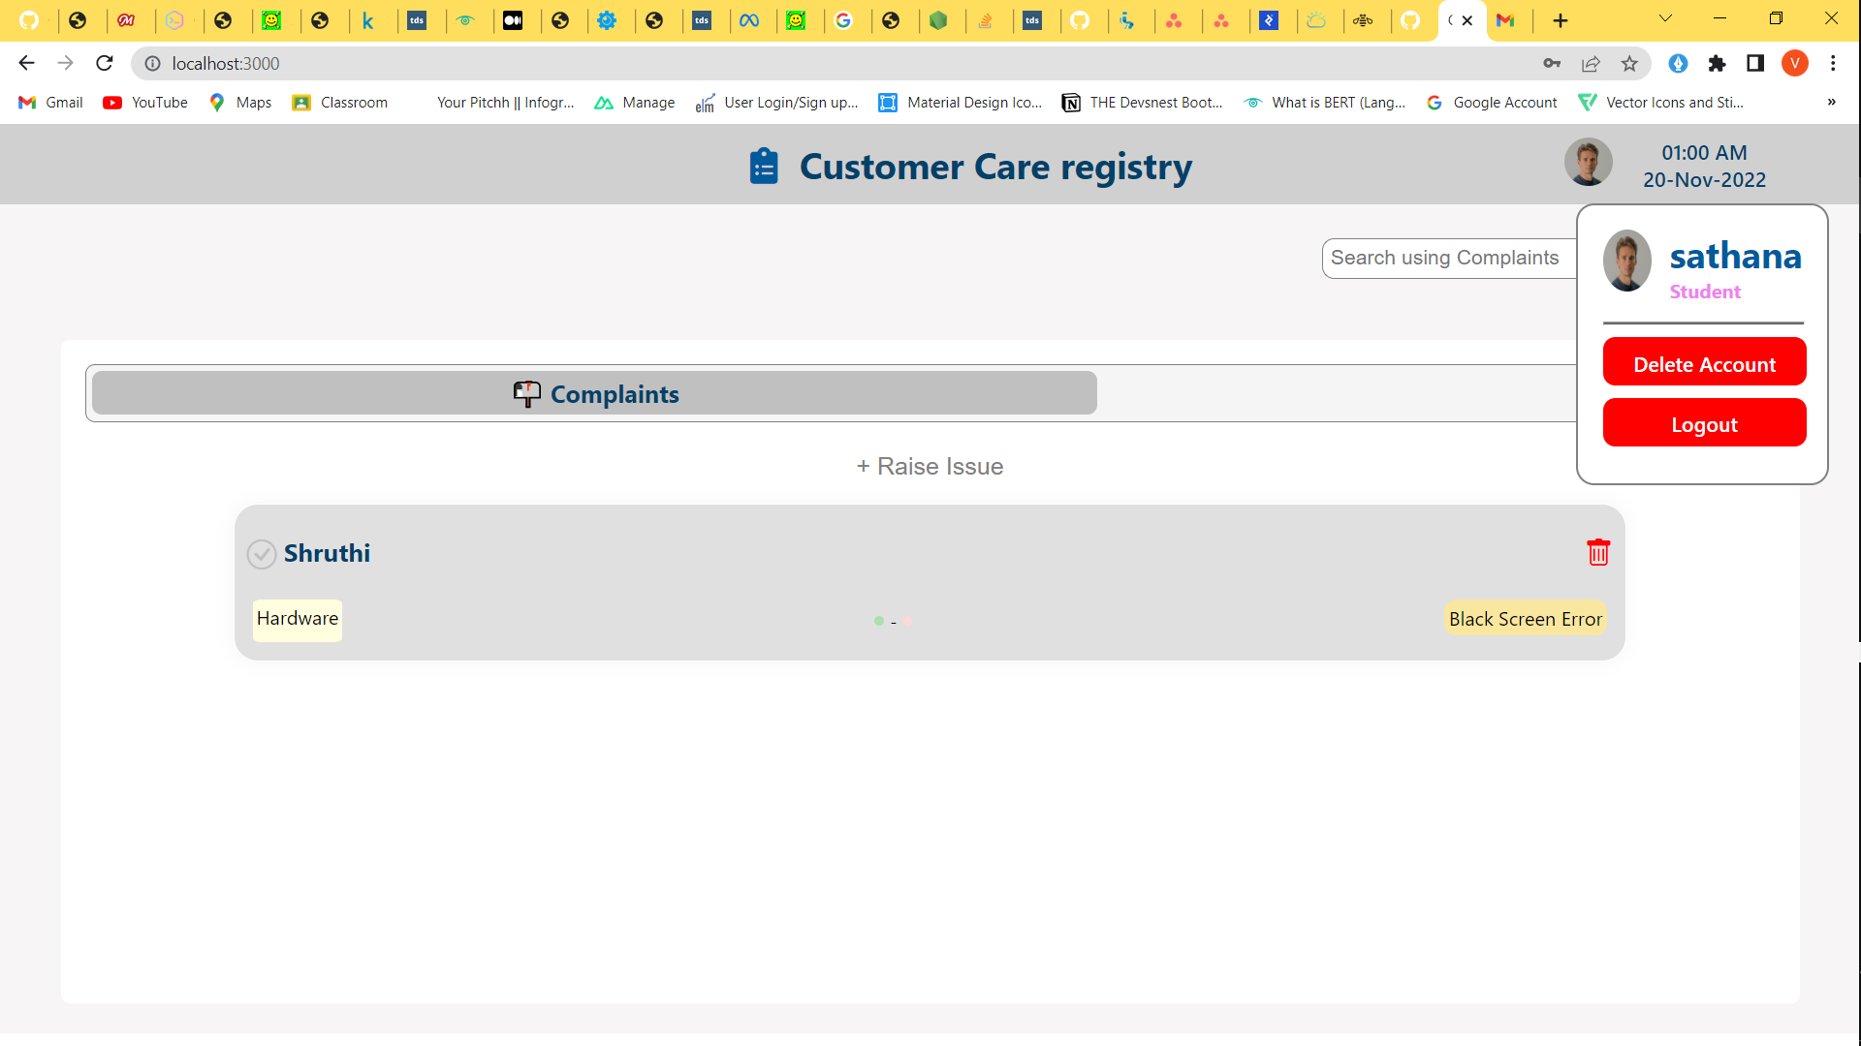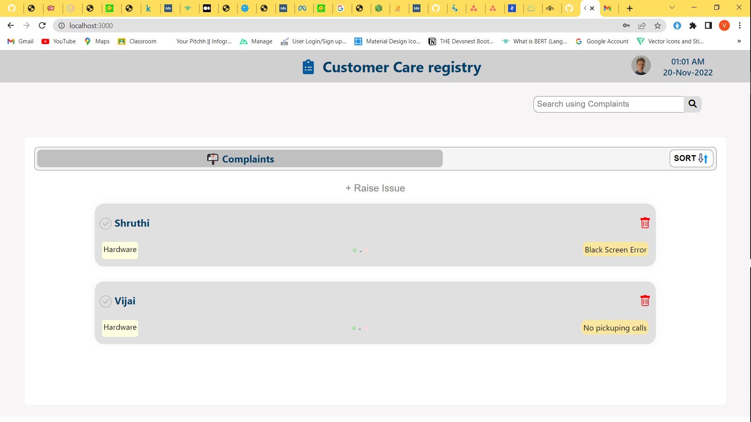

10. ADVANTAGES & DISADVANTAGES

Advantages:

- Enhances Better Customer Service
- Customer Care Registry systems provide businesses with numerous strategic advantages. One of such is the capability to add a personal touch to existing relationships between the business and the customers. It is possible to treat each client individually rather than as a group, by maintaining a repository on each customer’s profiles. This system allows each employee to understand the specific needs of their customers as well as their transaction file.
- The organization can occasionally adjust the level of service offered to reflect the importance or status of the customer. Improved responsiveness and understanding among the business employees results in better customer service. This decreases customer agitation and builds on their loyalty to the business. Moreover, the company would benefit more by getting feedback over their products from esteemed customers.
- The level of customer service offered is the key difference between businesses that lead the charts and those that are surprised with their faulty steps. Customer service efficiency is measured by comparing turnaround time for service issues raised by customers as well as the number of service errors recorded due to misinformation.
- A good business should always follow – up with customers on the items they buy. This strategy enables a business to rectify possible problems even before they are logged as complaints.

Disadvantages:
1. Only services for which a particular payment has been made are covered under the consumer protection act. However, it does not protect medical professionals, or hospitals, and covers cases when this act does not apply to free medical care.
- This act does not apply to mandatory services, such as water supply, that are provided by state agencies.
- Only two clauses related to the supply of hazardous materials are covered by this act. Consumer redress is not given any power by the consumer protection act.
- The consumer protection act focuses on the supply of ineffective products, but there are no strict regulations for those who produce it.

11. CONCLUSION
The researcher has highlighted how the system works, who are the main users, services and how they can deal with the proposed system. This paper presents an overview of the development and implementation of the Complaint Management System as a web-service based on cloud. The results obtained from the implementation are encouraging and promising for the development or more complex systems in the future as the Complaints Management is a complex and critical problem. Complaints and compliments are valuable source of information that organizations can use to improve program delivery and service. As regulatory and market pressures continue to mount upon companies, industry leaders will need to develop effective solutions or face the high costs inherent in failed technology implementations and weak customer relationships. The preferred alternative is a customerfocused complaints management solution that works. Finally the researcher believes that the presented model can be helpful in other fields of e-complaining in terms of Citizen Adaption and Citizen Loyalty.

12. FUTURE SCOPE
It is quite certain that with great precision the new-gen technology of Customer Care Registry solutions will help in the sales and marketing to a great deal. This will be done while calculating the better results attained by the marketing team.
The progression of CUSTOMER CARE REGISTRY in the future would mostly depend on how faster API’s redefines cloud platforms. And it is simply the beginning of API’s era of integrating CUSTOMER CARE REGISTRY solution with the business application.
Even though the benefits of CUSTOMER CARE REGISTRY sounds quite interesting while its implementation challenges are quite difficult to overcome. And with the advancement of CUSTOMER CARE REGISTRY technology every year, this trend of implementation barriers will keep rising.
In the near future, CUSTOMER CARE REGISTRY will be mostly analytical & net based. More trending technologies of CUSTOMER CARE REGISTRY such as data analytics & other matrices will be used to analyze the business performance.
Moreover, more user will be benefited due to the linkage of CUSTOMER CARE
REGISTRY along with social media as it will see more popularity in the coming days. Apart from this, the future CUSTOMER CARE REGISTRY will enable its user to exchange data over electronic devices more easily than ever.
Not to mention CUSTOMER CARE REGISTRY’s immense scope of being integrated with multiple other platforms in the future that will boost its functionalities resulting in great progress and development of company & organizational activities.

13. APPENDIX
GitHub & Project Demo Link

